Network security-PART1- WAN to LAN Preparation- Incoming traffic

Learning objective: Preparing the network environment to monitor **incoming** data from the WAN to LAN with pfSense.

**Task1**

Create the following diagram using MS Visio or any drawing tool of your choice. After creating the diagram, provide a description of the diagram in a paragraph or two. Please attach the file

**Internal Pentest –**Assuming that an attacker has access to the internal network, we can use Kali Linux with the IP address 10.0.0.2 to pentest the other machines in the private network. The focus of this assignment is to monitor incoming traffic as opposed to outgoing traffic in previous assignments. After installing a second pfsense, add two adapters, one that connects to Kali and one that connects to Windows 10. To trace internal traffic, we have to create a network (kali will be used in this example). Pfsense will be assigned WAN of 10.10.10.1 with a LAN of 192.168.1.1, windows 10 adapter will be assigned 192.168.1.2 as the default gateway of 192.168.1.1. From this diagram we should be able to ping windows from pfsense, ping kali from pfsense. For the challenge aspect of it I pinged pfsense in Kali by assigning WAN and LAN rules in pfsense GUI.

After completing the installation process, we can proceed with pfSense configuration. The steps to configuring pfSense are shown in the next section. Before that, let us make changes to VM network settings for our pfSense instance. This interface is publicly accessible in our lab. So, we can access this IP address from any computer connected to the same Wi-Fi network. You may look at the network diagram I have shown below to better understand this. To do this, we are going to setup an IP address for the interface le1.

In the above screen, just enter 2 in order to select “Assign Interfaces”. Then, we should see the available interfaces. Since we are going to configure the second interface, we will choose “2” again. This should allow us to configure the private interface, which is le1 (LAN).

We will then be prompted for the LAN IP address.

In my case, I am providing it 10.0.0.1.

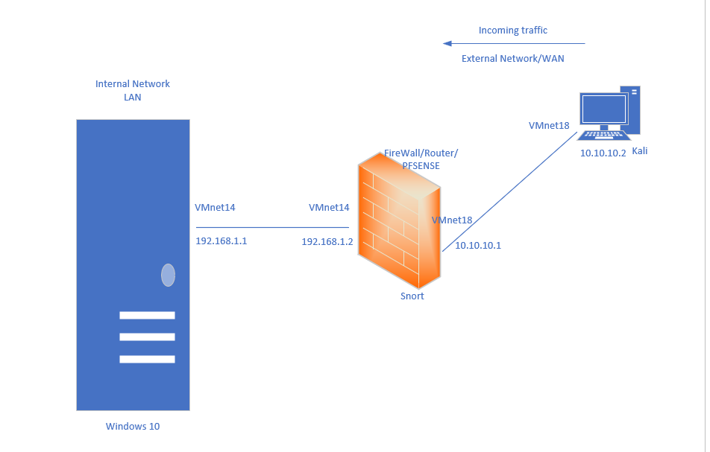



**Task2**

Part 1: Configuring Virtual Networks

In Pfsense add two network adapters. One connecting to LAN (e.g., VMnet19) and second one connecting to WAN (e.g. VMnet18)

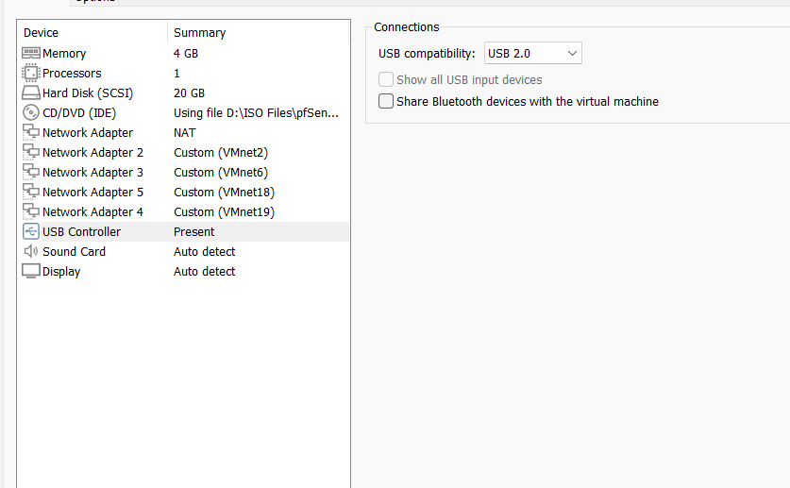

Part 2: Connecting Devices with pfSense

**Configure Kali Linux:**

In Kali’s VM settings, set the network adapter to Custom and select VMnet18 from the dropdown list.

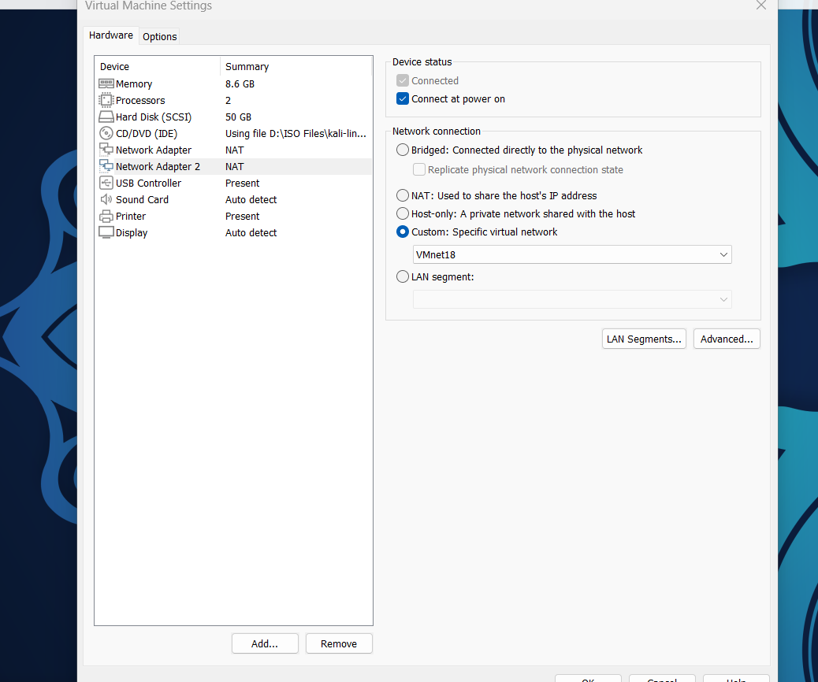

I’ve added the adapter that connects to pf sense in Kali

**Configure Windows 10/11:**

In Windows 10/11 VM settings, set the network adapter to Custom and select VMnet19 from the dropdown list.

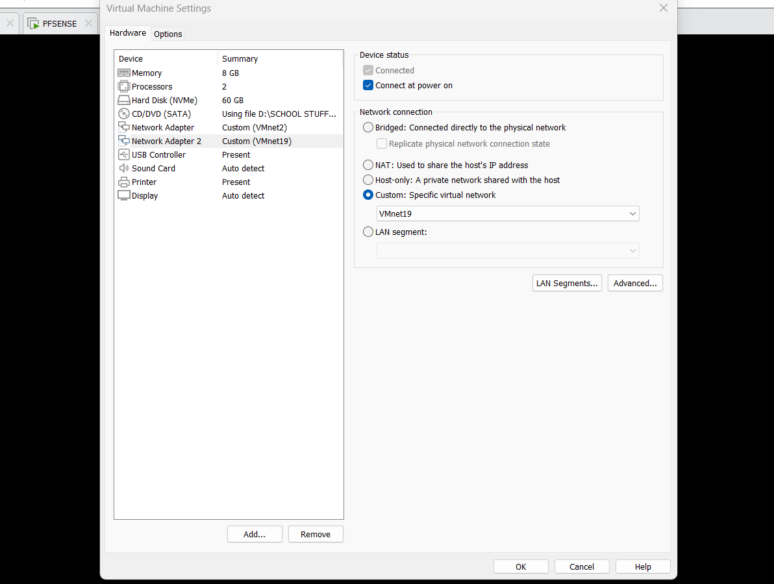

Part 3: Configuring IP WAN and LAN in pfSense

Run pfSense: Start pfSense and type "2" followed by Enter.

**Configure IP for WAN:**

a. Select WAN by typing "1" and Enter.

b. Type "n" to cancel automatic IP address assignment.

c. Enter the IP address for WAN as 10.10.10.1.

d. Specify the network mask as 8 and press Enter.

e. Skip configuring IPv6 by typing "n" and Enter.

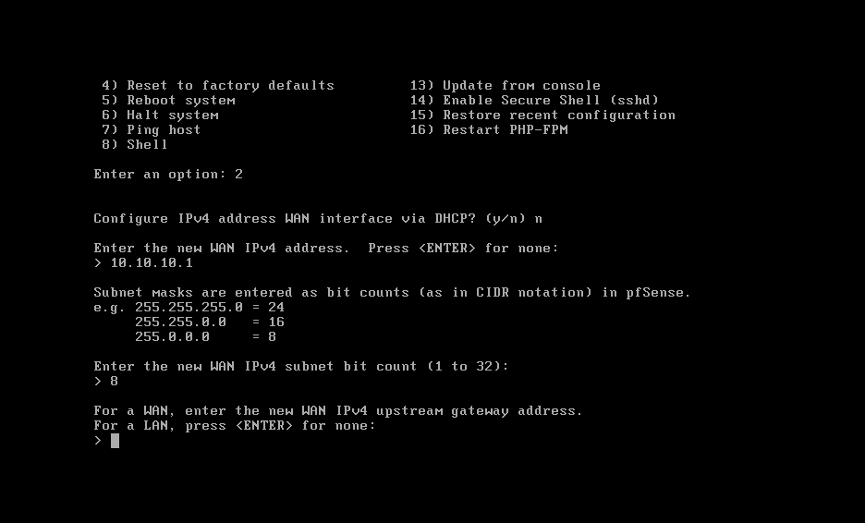

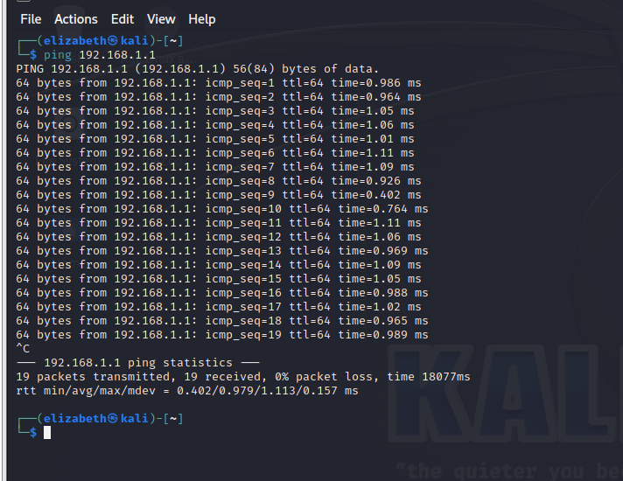

This is pinging the LAN in pfsense

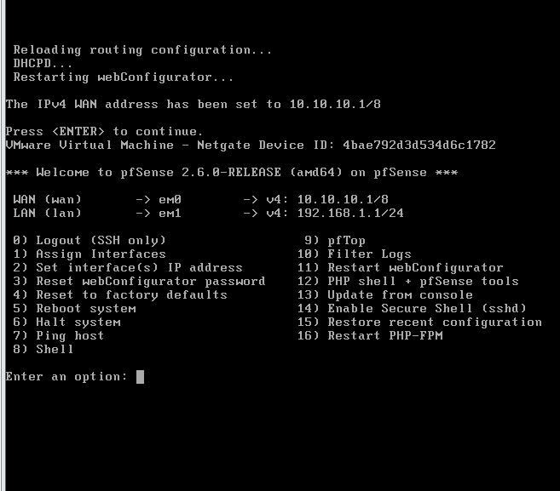

Assign WAN as 10.10.10.1

Ping pfsense from windows

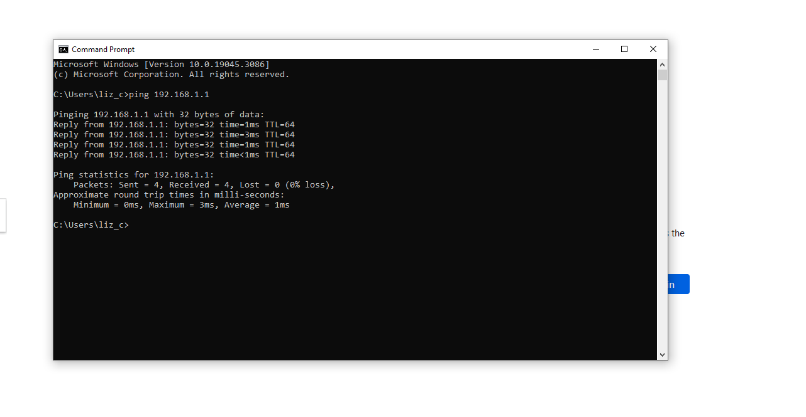

Ping kali from pfsense shows the reply

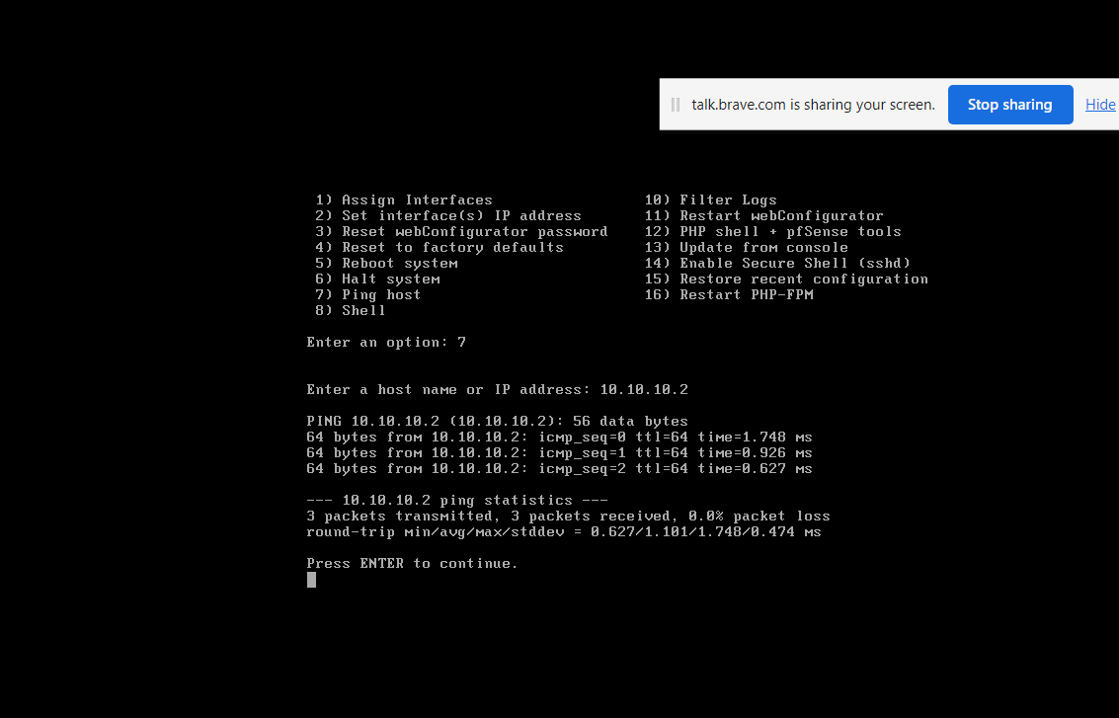

(Note: after each configuration, ensure to restart vm’s in order for changes to be effective)

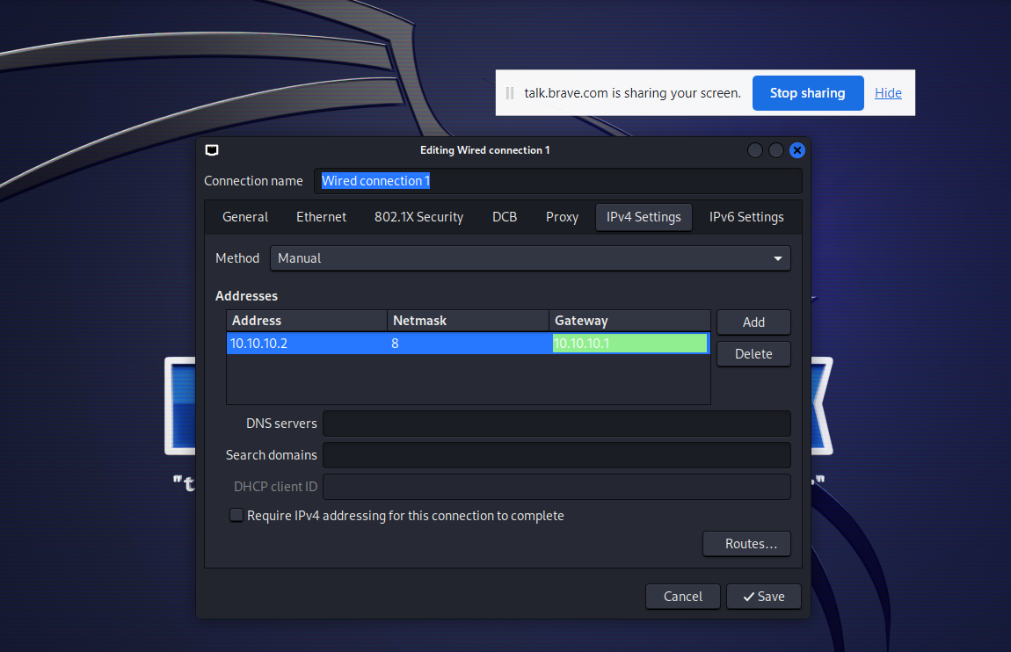

Assign IP in Kali and gateway of 10.10.10.1

Below is where I am pinging the WAN of 10.10.10.1 from Kali to pfsense

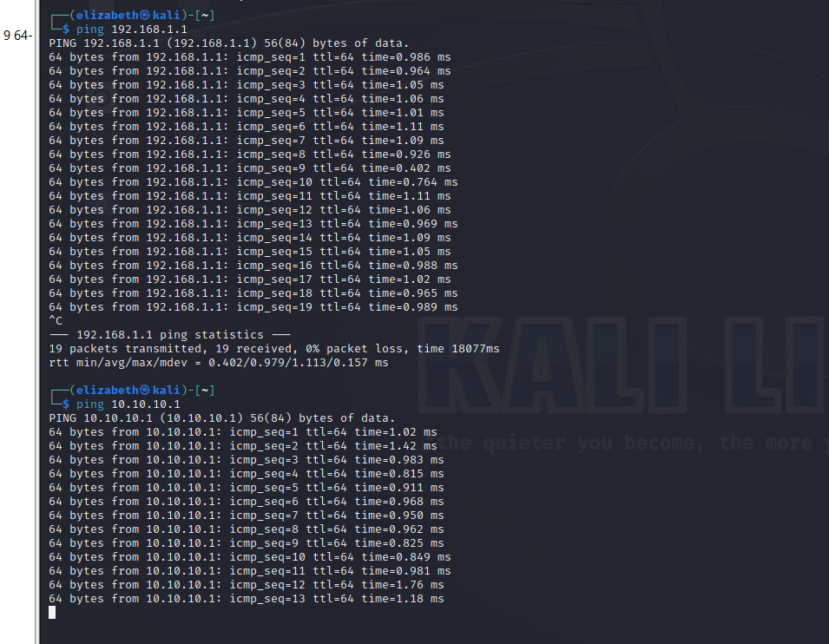

CHALLENGE COMPLETED!!!

In order for the above to work ICMP rules for WAN and LAN has to be configured in pfsense GUI

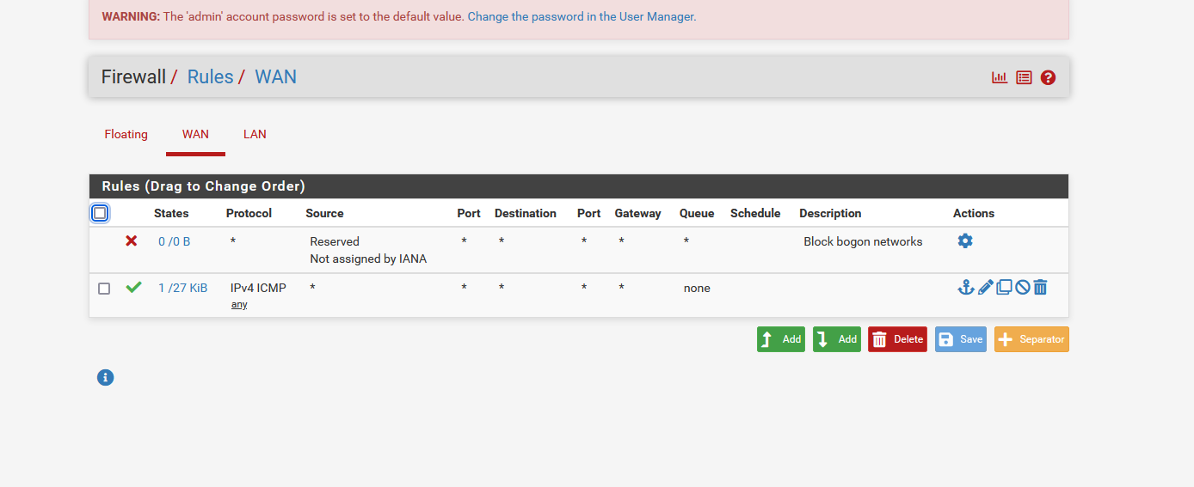

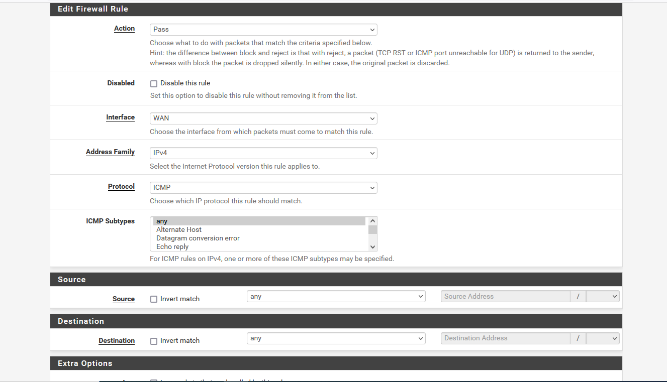

Configure the rules in Firewall as shown below. (ensure you are selecting options for WAN and LAN when creating rules

In the interface GUI uncheck block private networks

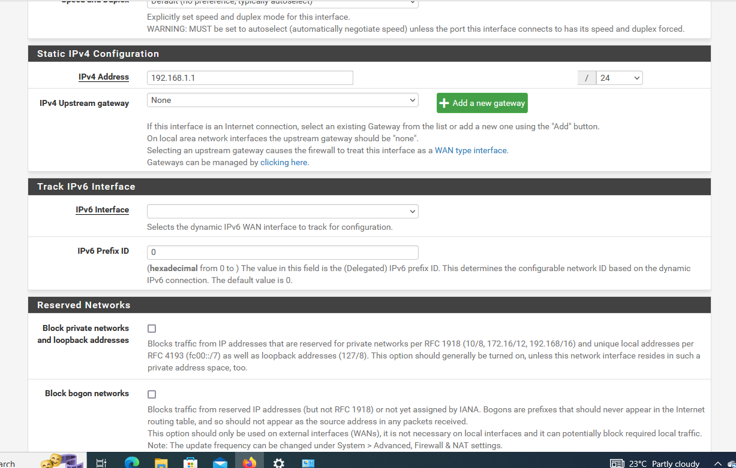

Note: Configure IP for Pfsense LAN if not configured

Part 4: IP Configuration in Kali Linux

1. Create a new configuration file:

a. Open a terminal in Kali Linux.

b. Use a text editor to create the configuration file: sudo nano /etc/network/interfaces.d/vmnet18

1. Add the following configuration lines to the file:

auto eth0 iface

eth0 inet static

address 10.10.10.2

netmask 255.0.0.0

gateway 10.10.10.1

1. Save the changes
2. Restart the network service

In the terminal, type: **sudo systemctl restart networking**

1. Verify the new IP address:

a. Type "ifconfig" in the terminal.

b. Check if the IP address has changed

NOTE: You can assign IP address to Kali manually through GUI

Watch this video

<https://www.youtube.com/watch?v=dXBnsnMR2WI>